ICS 2412 – Digital image Processing

MATLAB Practical Question

Image Sampling and Quantization

Name: Daisy Oduor

Reg No: SCT211-0040/2019

**Task 1: Image loading and display.**

The image used is that of the jkuat main gate, and the output from matlab is as below:

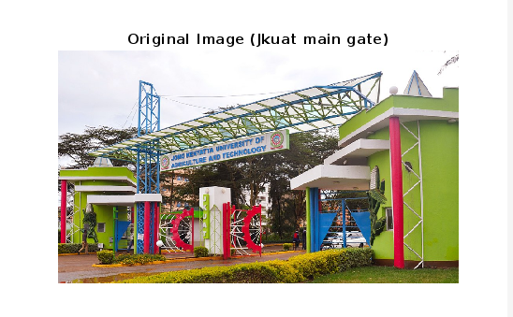

**Task 2: Image Sampling:**

Sampling was conducted on the image using various factors that is 2, 4 and 8. The results are as displayed below. The first one is the original image, the rest are the results after conducting sampling.

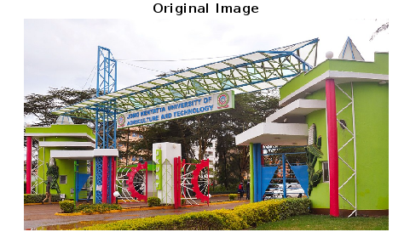

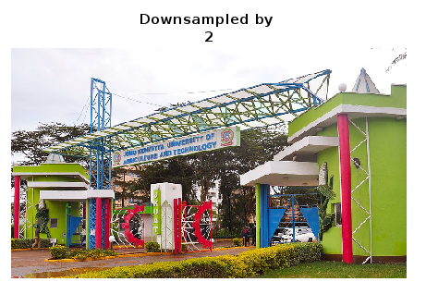

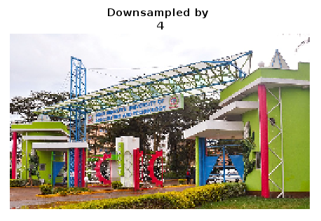

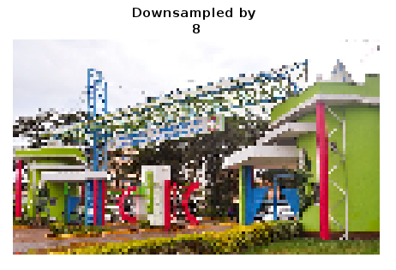

**Task 3: Image Quantization**

Quantization was done for different levels i.e. 64, 16, 4 and 2. The results are as below.



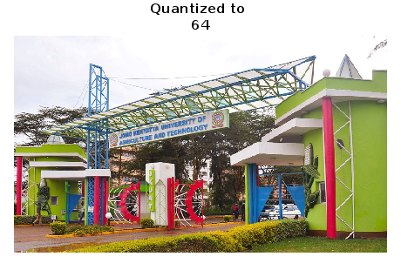

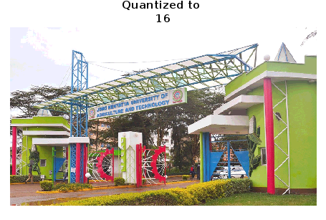

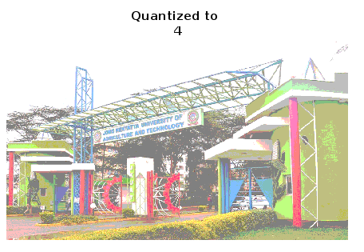

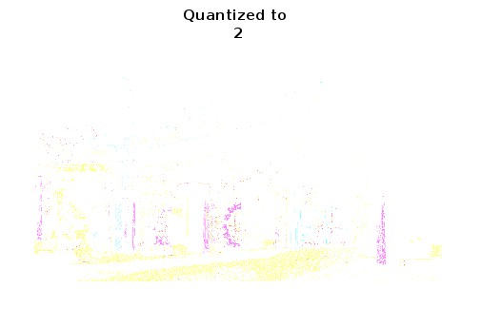

**Task 4: Analysis/Discussion.**

For sampling, the image resolution and detail is reduced as the factor is increased. At factor 8, most of the finer details of the image have been lost, and the image is displayed in forms of dots. The effect of downsampling is also more noticeable for higher factors than for the lower factors.

For Quantization, the color depth reduces from as the quantization level reduces. Level 64 has a higher color depth while level 2 has a very low color depth, and the colors used are very discrete. For level 2 it seems like the focus is more on the color, than on the image. The higher quantization levels (64) also give more realistic/natural images while the lower quantization levels look more artistic than real.